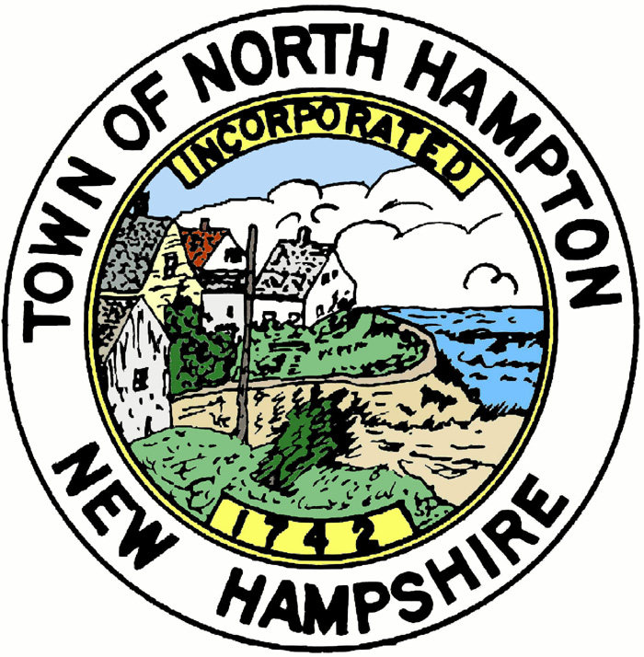
AGENDA
TOWN OF NORTH HAMPTON
Planning Board
Sign Ordinance Ad hoc Committee
June 27, 2016 at 1:30pm
Mary Herbert Conference Room
233 Atlantic Avenue

The Planning Board’s Sign Committee will meet on Monday, June 27, 2016 at 1:30 pm in the Mary Herbert Conference Room. The Committee will be discussing possible amendments, changes, and additions to the Sign Ordinance.

Respectfully submitted,

Nancy Monaghan
Planning Board
Posted:
Town Clerk’s Office
Town Office
Town Hall
Library
www.northhampton-nh.gov

